CS 4649 – RIP
Group Homework 2: Motion Planning

Inder Dhir, Ajmal Kunnummal, Sagar Laud, James Liu, Richard Stauffer
11/10/14

Question 1: Navigation Planning - Bug Algorithms for Point Robot
Part a)
Bug1 on Domain1
Euclidean = 200.56
Total Distance = 604.33
Ratio = 3.01322

Bug1 on Domain2
Euclidean = 140
Total Distance = 1926
Ratio = 13.75714

Part b)
Bug2 on Domain1
Euclidean = 200.56
Total Distance = 261.37293
Ratio = 1.3032

Bug2 on Domain2
Euclidean = 140
Total Distance = 3702
Ratio =26.4428

Question 2: Navigation Planning - Potential Field Navigation for Point Robot
Part a)
Euclidean = 200.56
Total Distance = 229
Ratio = 1.1417




Part b)



Question 3: Manipulation Planning - Differential Kinematics
Part a) Refer to the video “3a Video.mp4” for the video of the arm as it moves from initial to goal pose.
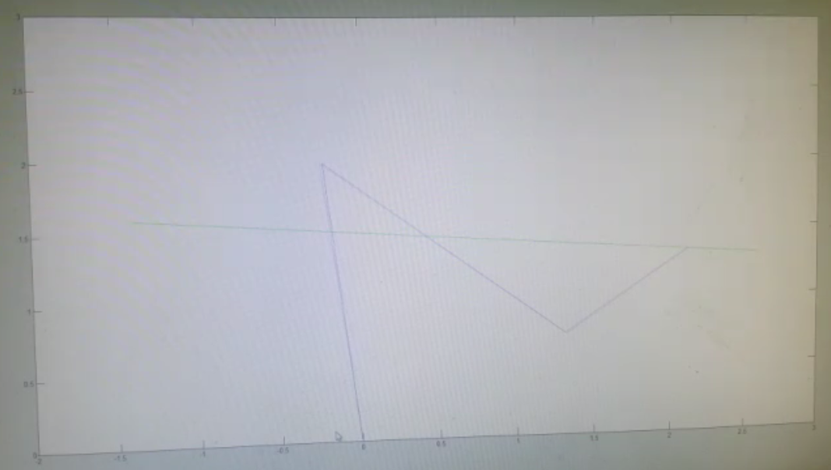
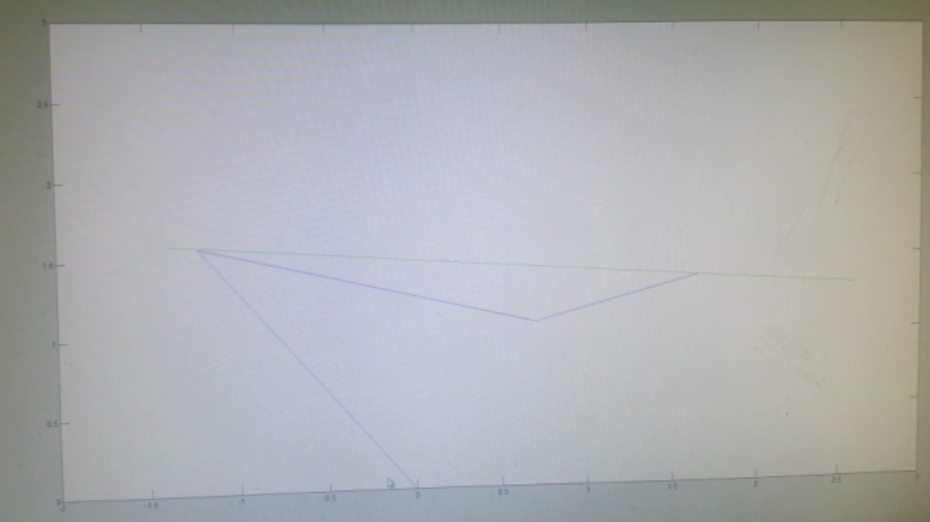

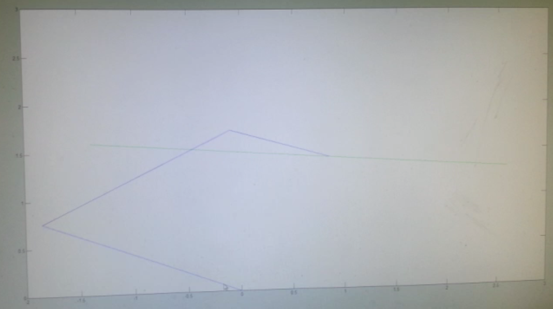
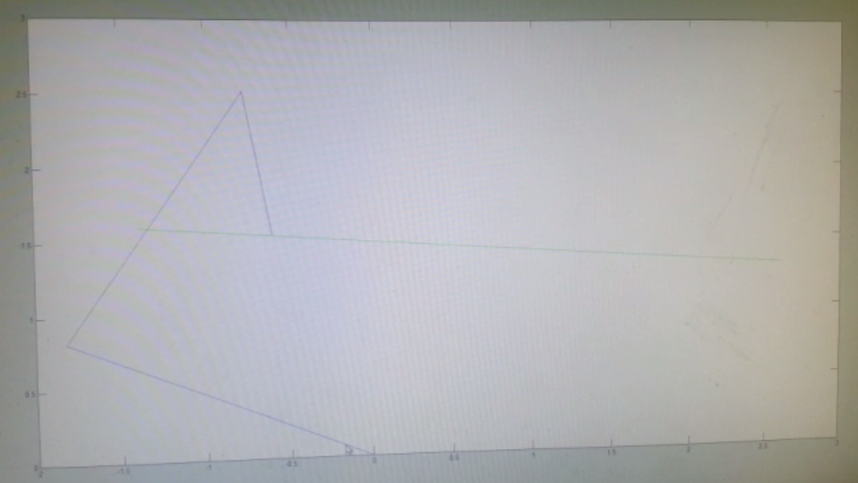

Part b)
In order to account for joint limits and collisions we implemented the following changes: For each of the joint positions we calculated the field potential in order to figure out the gradient around them. If they got within a minimum threshold distance from an obstacle, this kicked it and directed the joint away from the obstacle.

We implemented two simulations of two different obstacles in order to demonstrate the effectiveness of our obstacle avoidance. These can be found in video files “3b video 1.mp4” and “3b video 2.mp4”

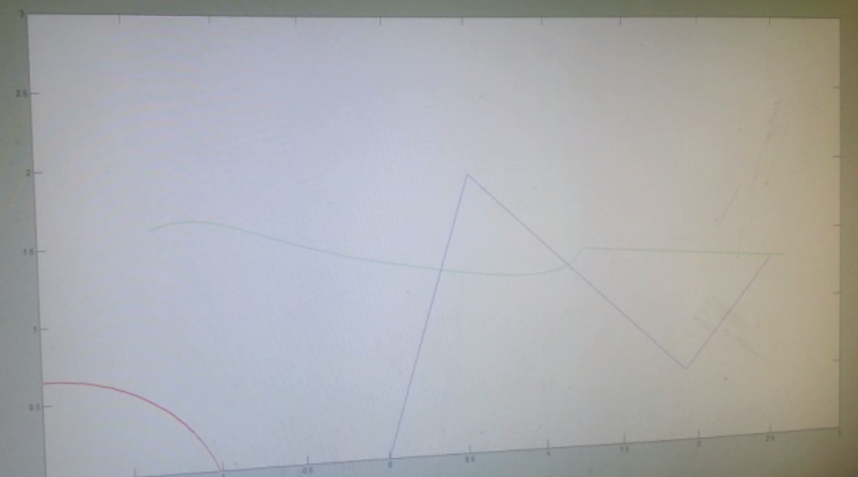
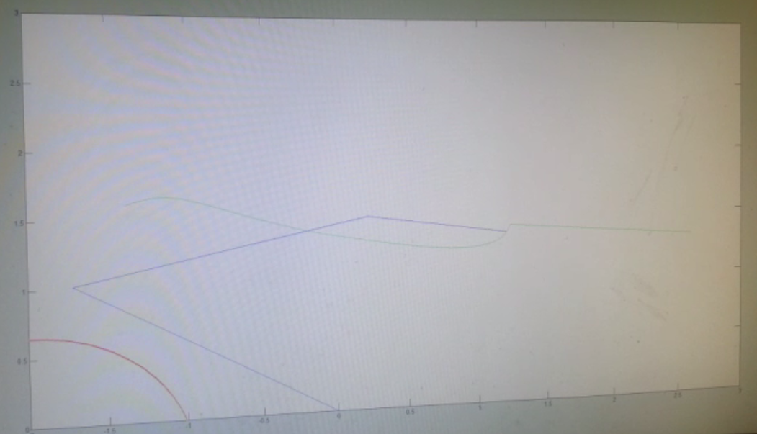

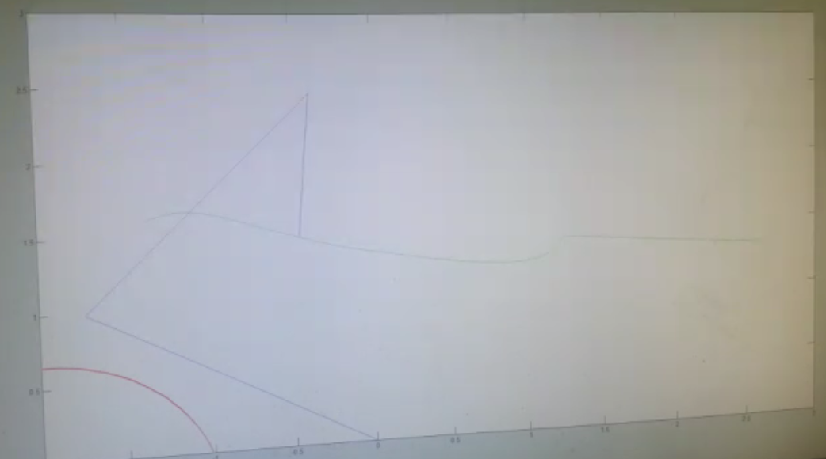
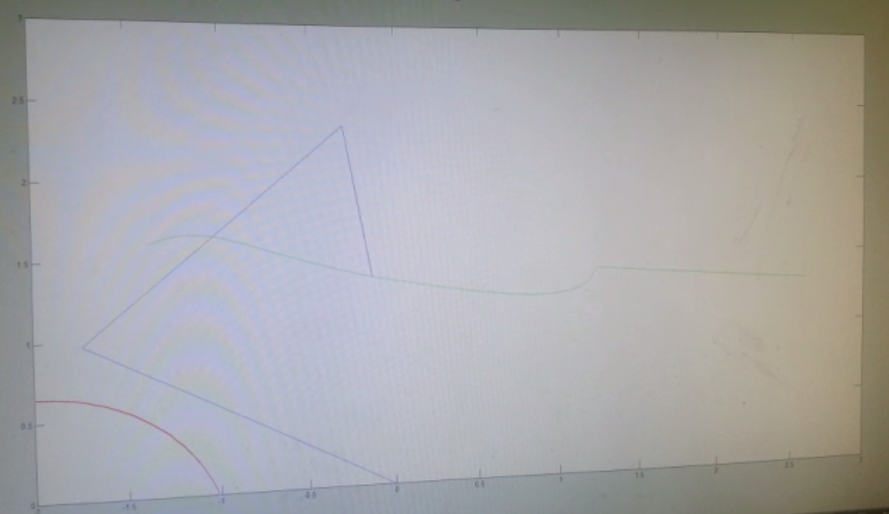
Video 2 for Problem 3 part B

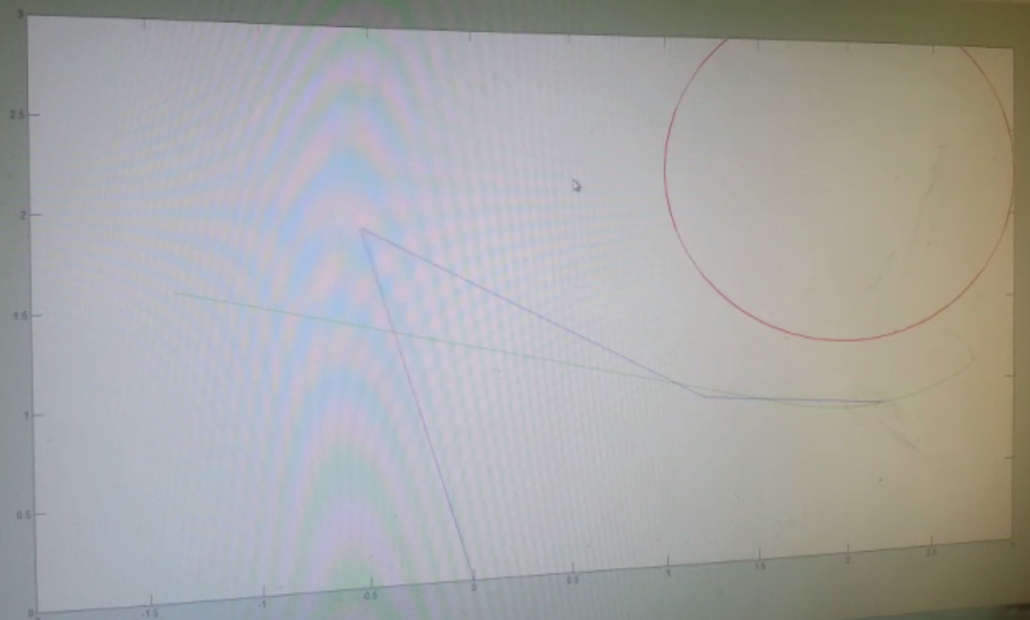
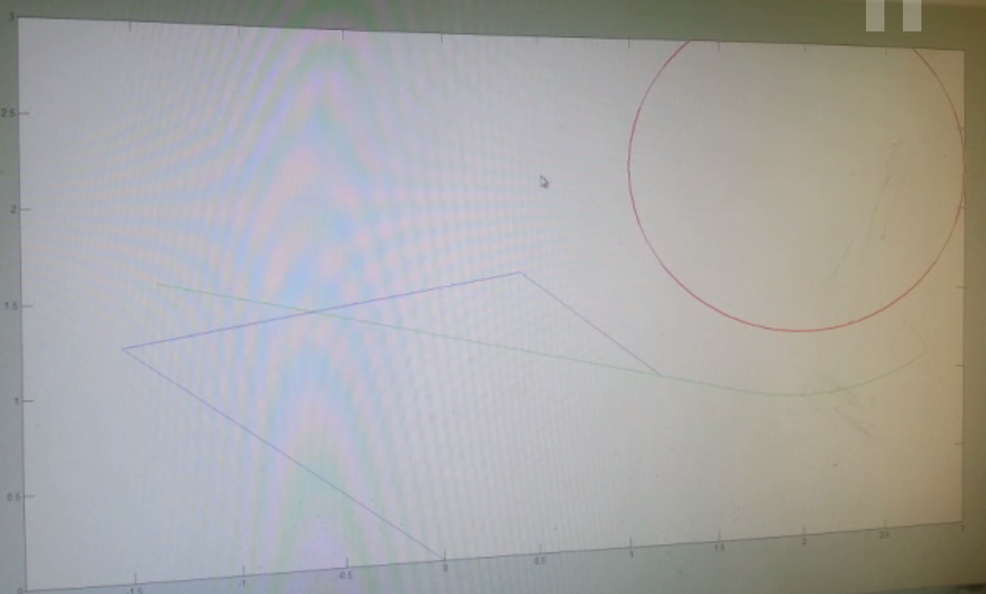
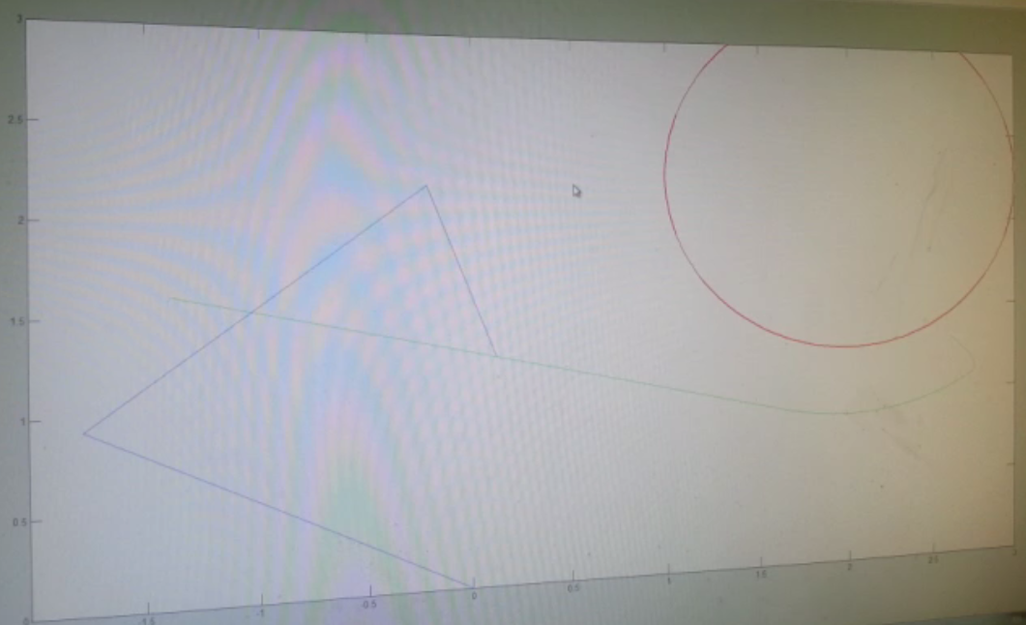
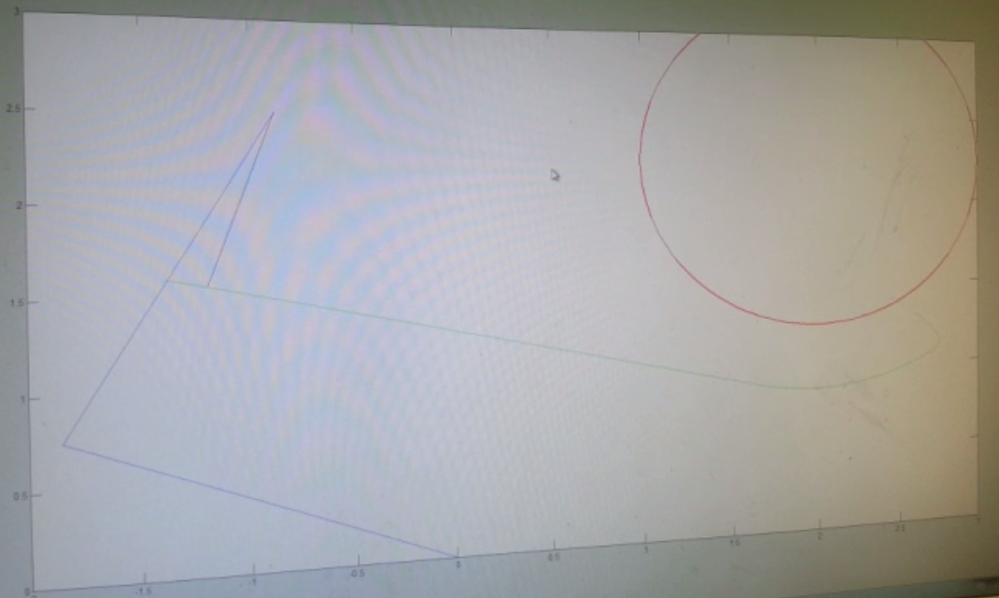
Question 4: Manipulation Planning – RRTs
Part a) This is a series of images chronicling the process of RRT generation without obstacles.
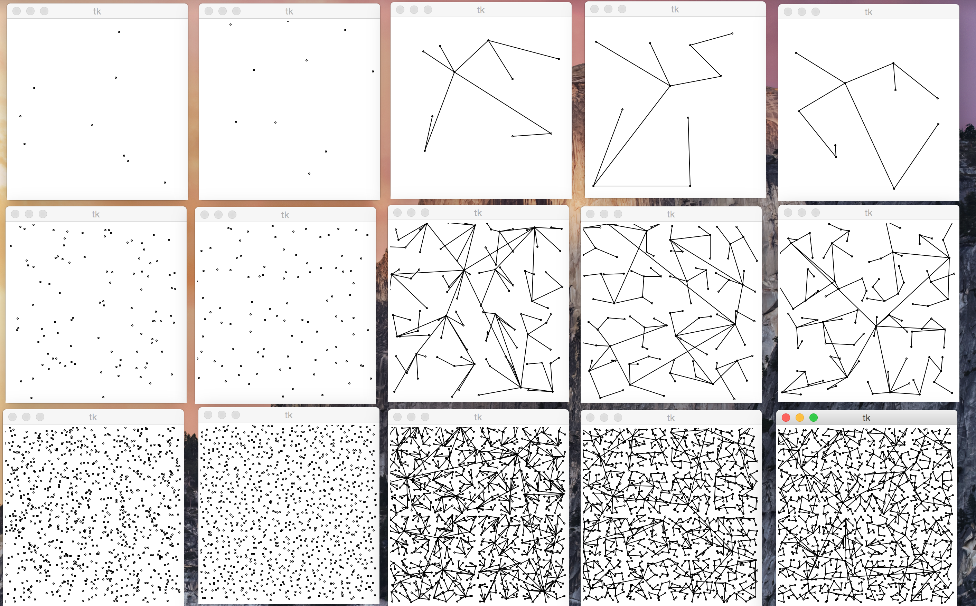

Part b)
Part c)
Part d)
Part e)

Question 5: Manipulation Planning - RRT with Task Constraints

Contributions:

